Oweiss Demand Curve Revisited

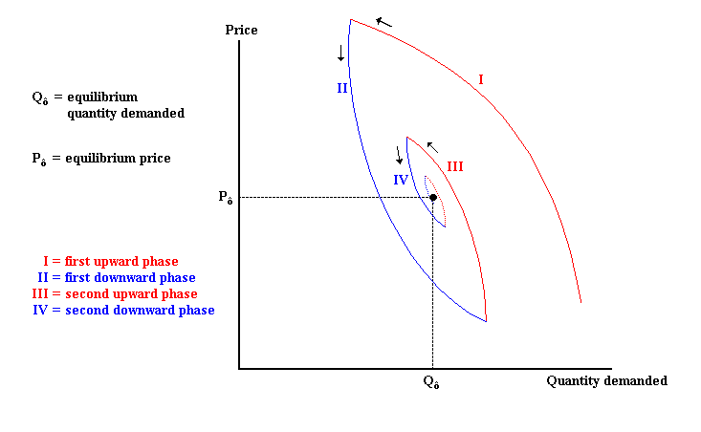

Source: Ibrahim M. Oweiss, “Economics of Petrodollars”, in H. Esfandiari & A. L. Udovitch, The Economic Dimensions of Middle Eastern History, The Darwin Press, Inc. Princeton NJ, 1990. p. 193

